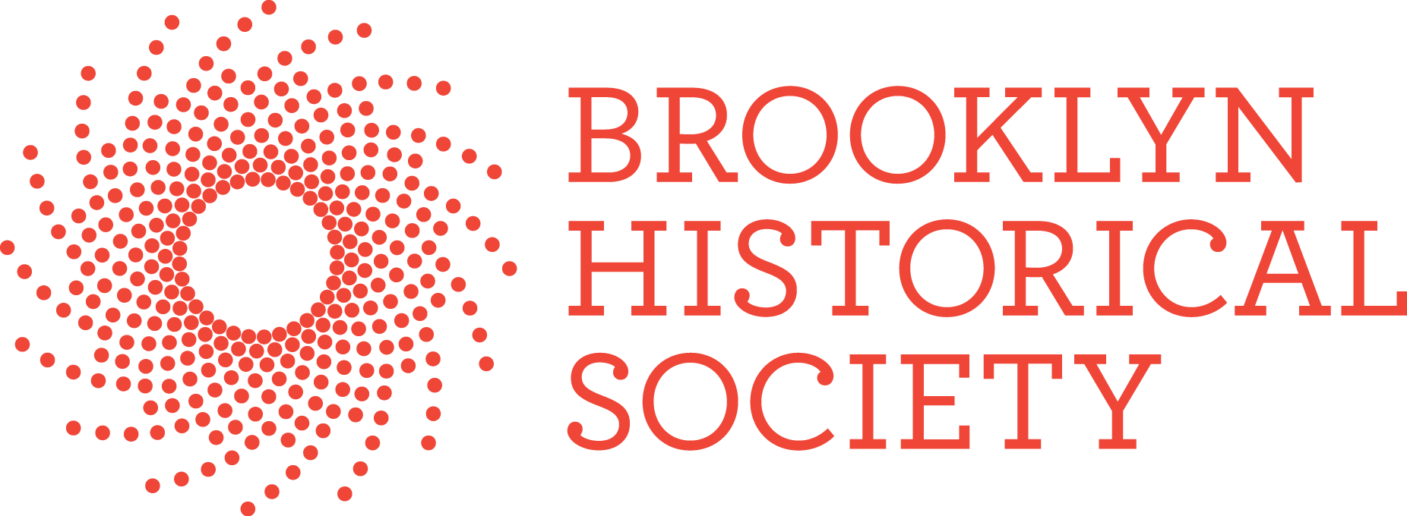
For Immediate Release
Press Contact:
Ondine Jean-Baptiste
Ojean-baptiste@brooklynhistory.org
718 222 4111 ext 356

BROOKLYN HISTORICAL SOCIETY HONORS DOWNTOWN BROOKLYN PARTNERSHIP PRESIDENT REGINA MYER AT FALL GALA

Gala raised $ 556,600 for BHS’s nationally recognized education programs which serve over 15,000 New York City students and teachers each year

Event also recognized writer and queer historian Hugh Ryan, author of the ground-breaking book, “When Brooklyn Was Queer”

(November 15, 2019) Brooklyn, NY --- On Wednesday, November 13, Brooklyn Historical Society (BHS) brought together hundreds of supporters for its fourth annual Fall Gala at the Liberty Warehouse in Red Hook. The event raised vital funds to support BHS’s wide-ranging education programs which include free school programs, youth engagement and afterschool programs for teens, teacher professional workshops, and a variety of free, digital curricula. Eighty percent of the students served by BHS education programs come from Title I schools. Programs take place at BHS’s two locations, on Pierrepont Street and in DUMBO, as well as at the Brooklyn Navy Yard.
The evening celebrated Regina Myer whose storied career includes her role as president of Brooklyn Bridge Park, where she oversaw the transformation of 1.3 miles of industrial waterfront into one of New York City’s most popular destinations. Myer currently leads the Downtown Brooklyn Partnership, a not-for-profit local development corporation that serves as the primary champion for Downtown Brooklyn’s stature as a world-class business, cultural, educational, residential, and retail destination. Earlier Myer was the senior vice president for planning and design at Hudson Yards Development Corporation, and Brooklyn Borough Director for the New York City Planning Department, where she led the comprehensive redevelopment of the Greenpoint/Williamsburg waterfront, the rezoning of Downtown Brooklyn for high density office and retail development, and numerous neighborhood rezoning initiatives.
Also honored was Hugh Ryan, founder of the Pop-Up Museum of Queer History and curator of BHS’s 2019 exhibition, “On the Queer Waterfront,” the first exhibition ever focused explicitly on the lesbian, gay, bisexual, transgender, and queer history of Brooklyn. The exhibition coincided with the launch of Ryan’s book, “When Brooklyn Was Queer,” which The New York Times called a “boisterous, motley new history “and an “entertaining and insightful chronicle.”
The evening at the Liberty Warehouse started with a cocktail hour where 262 guests took in the magnificent expanded views of New York Harbor and the Statue of Liberty, and continued with dinner, dessert and dancing.

About Brooklyn Historical Society
Founded in 1863, Brooklyn Historical Society is a nationally recognized urban history center dedicated to preserving and encouraging the study of Brooklyn's extraordinary 400-year history. Located in Brooklyn Heights and housed in a magnificent landmark building designed by George Post and opened in 1881, today's BHS is a cultural hub for civic dialogue, thoughtful engagement and community outreach. In May 2017 BHS opened a second site in DUMBO’s Brooklyn Bridge Park.

###

